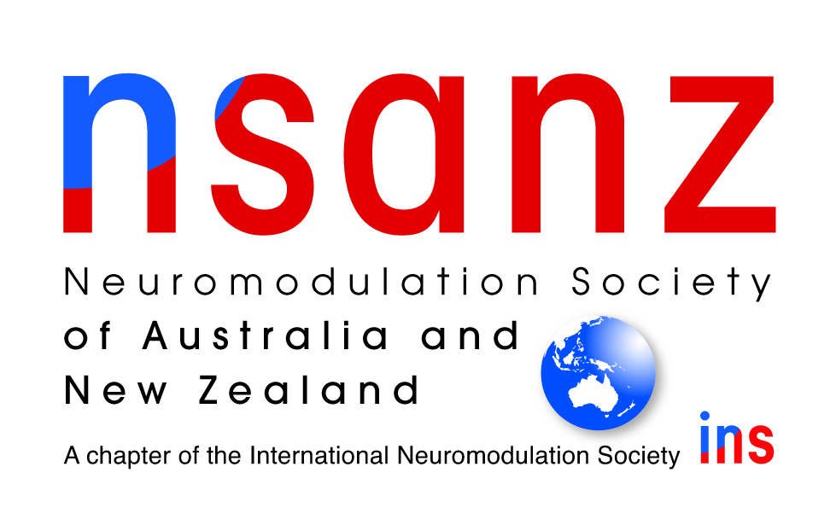
Annual General Meeting (AGM)
13 August 2022
5pm (AEST)
Proxy Form

I, the undersigned:
being a financial member of the Neuromodulation Society of Australia and New Zealand (NSANZ),
Hereby appoint: _____________________________________ (person or chair)
Or failing him/her: __________________________________________________
as my proxy to vote on my behalf at the Annual General Meeting of the Neuromodulation Society of Australia and New Zealand (NSANZ), to be held on Saturday 13 August, 2022 at 5pm and at any adjournment thereof.
Signed this___________________ day of __________________________ 2022
Member__________________________________________________________

Return to: NSANZ Secretariat
Email: secretariat@nsanz.org.au

by close of business AEST on Thursday 11 August 2022

